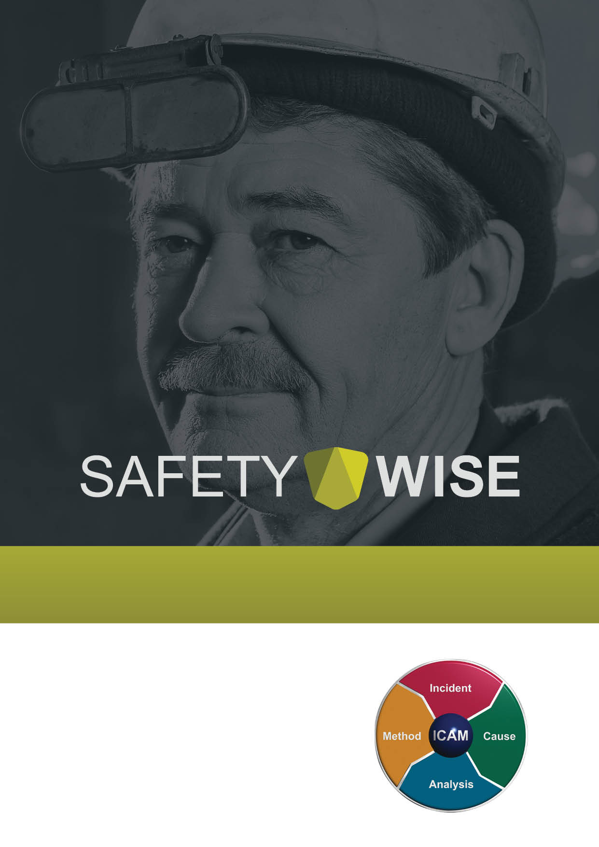

INCIDENT INVESTIGATION REPORT into
Electrical Incident at Westbank Private Hospital
SWS 04 Ver 1 10 December 2021

Prepared for the sole purpose for advancing safety.
Confidential and subject to limited distribution.

Prepared by [Name]
Safety Wise Solutions Pty Ltd

CONTENTS OF REPORT

1.0 Introduction 3
2.0 Scope of Investigation 3
3.0 Methodology 3
4.0 Investigation Team 4
5.0 Incident Description 4
5.1 Incident Details 4
4.2 Background 5
4.3 Events Leading up to the Incident 5
4.4 Incident Event 6
4.5 Events Post Incident 6
4.6 Photographs 7
4.7 Timeline 8
5.0 Data Collection 9
5.1 People 9
5.1.1 Supervision and Work Instructions 9
5.1.2 Role, Training, and Experience 10
5.1.3 Personnel Incident Reporting 11
5.1.4 Other Factors 11
5.1.5 Conclusions 11
5.2 Environment 12
5.2.1 Air-conditioning Unit Location 12
5.2.2 Conclusions 12
5.3 Equipment 12
5.3.1 Air-conditioning Unit 12
5.3.2 Conclusions 12
5.4 Procedures 12
5.4.1 Electrical Isolation 12
5.4.2 Incident Reporting 13
5.4.3 Conclusions 13
5.5 Organisation 13
5.5.1 Procedures and Risk Management 13
5.5.2 Accountability and Responsibility 14
5.5.4 Previous Incident 14
5.5.5 Conclusions 14
6.0 Key Findings 14
6.1 Basic Cause 14
6.2 5 Whys Analysis 14
7.0 Recommendations 16
7.1 Communication via Safety Alert (Administration) 16
7.2 Procedures (Administration) 16
7.3 Risk Management 16
7.4 Accountability and Responsibility 16
7.5 Behavioural Markers 16
8.0 Management Review of the Investigation Report 17
8.1 Management Review 17
8.1.1 Distribution 17
8.1.2 Implementation of Corrective Actions 17
8.1.3 Implementation Monitoring 17
8.1.4 Analyse Effectiveness 17
8.1.5 Document Archival 17
9.0 Significant Learnings 18
9.1 Isolation 18
9.2 Accountability and Responsibility 18
9.3 Incident Reporting 18
10.0 Appendices 19
10.1 Corrective Action Plan 19
11.0 Report Sign-off 20

Introduction
In November 2021 A&C Aircon and Electrical, who provide electrical and air-conditioning services in the Wide Bay Region of Queensland, engaged Safety Wise Solutions to investigate an electrical incident where an employee received an electric shock while conducting repairs to an air-conditioning unit at Westbank Private Hospital, Bundaberg, Queensland.

Scope of Investigation
The scope of work required a quality and systemic investigation methodology using the 5 Whys methodology to determine the contributing factors, that affected the performance of the work that led to the employee receiving an electric shock, by identifying deficiencies, if any, within the organisation’s systems and processes.
The focus of the investigation is at an organisational systems level to identify the root causes and includes both cultural and behavioural aspects, if applicable, where operational discipline to the application of process may, or may not, have contributed to the incident.

Methodology
The methodology to conduct this investigation aligned to the principles of the 5 Whys technique using the following steps which included:
- Data Collection and Data Organisation to determine contributing factors.
- Data Analysis of the contributing factors.
- Corrective Actions to address the contributing factors.
- Key Learnings for A&C Aircon and Electrical.
In conducting this investigation, the following processes and techniques were applied.
- Provision of an independent incident investigation technical expert (Lead Facilitator) providing advice to the investigation team leader nominated by A&C Aircon and Electrical.
- Site appointed members to the investigation team.
- Site visit.
- Communication of the scope and intent of the investigation to key stakeholders to gain support via a pre-investigation meeting and post-site visit meeting with A&C Aircon and Electrical management.
- Obtain complete access to people for either interviews and/or discussions.
- Obtain complete access to documentation, equipment, computer process data, CCTV footage, and voice recordings relevant to the incident that will assist in the investigation.
- Allow access for taking of photographs relevant to the incident.
On completion of the investigation, the Lead Facilitator provided a draft report, using the SWS Investigation Report format, to A&C Aircon and Electrical for review and comment prior to delivering this final Report.

Investigation Team

Name | Position | Company
[Name] | Lead Facilitator (independent) | Safety Wise Solutions
[Name] | Safety Advisor | A&C Aircon and Electrical

5.0 Incident Description

5.1 Incident Details
Brief Description: An A&C Aircon and Electrical employee received an electric shock to his hand while repairing an air-conditioning unit in Shades Cafeteria situated in the Westbank Private Hospital, Bundaberg, Queensland.
This event was reported by A&C Aircon and Electrical to WorkSafe Queensland.
Location: Shades Cafeteria, Westbank Private Hospital,  46 Liberty Street, Bundaberg, Queensland | Area: Inside the kitchen and food preparation area
Incident Date: Wednesday, 30 November 2021 Time: Approx. 10:50hrs
Report Date: Wednesday, 30 November 2021 Time: Approx. 15:10hrs

Notification to Client: Wednesday, 30 November 2021
A&C Aircon and Electrical Incident Number: 1003
Incident Type: Electric Shock
Details of Entities
Building Owner (Owner of air-conditioning asset): Westbank Private Hospital
Leasee: Shades Cafeteria
Contractor: A&C Aircon and Electrical (engaged by Shades Cafeteria)
Details of Person/s Involved
Name: [Name] Role: Technician Employer: A&C Aircon and Electrical
Injuries Sustained:
Electric shock to the left hand.

Details of Plant
Air-conditioning Unit: Delonghi Air-conditioning Unit
Model No. - DPWI DCT 70E
Damage: Nil
Environmental Impact: Nil
Risk Ranking - Severity / Consequence Level
Actual Ranking: Level 2 - Minor
Potential Ranking: Level 4 - Major

The risk ratings above were assessed using the Incident Severity Classification Chart in the A&C Aircon and Electrical Incident Management Procedure, Document No. P0002.
4.2 Background
Shades Cafeteria is an independently owned business operating within the Westbank Private Hospital. In early November 2021, Shades Cafeteria Head Chef noticed problems with the cafeteria food preparation and kitchen area air-conditioning unit. It was noisy and not cooling as required. The Head Chef discussed the issue with the Shades Cafeteria Manager.
On 10 November 2021, the Manager of Shades Cafeteria sought approval from the Assets and Infrastructure Maintenance Manager of Westbank Private Hospital to engage a contractor to repair the faulty air-conditioning unit.
Westbank Private Hospital gave approval to repair the air-conditioning unit using an approved contractor from an approved list of contractors.
Shades Cafeteria Manager engaged A&C Aircon and Electrical (from the approved list of contractors) to carry out the repair work.

4.3 Events Leading up to the Incident
- On Thursday, 18 November 2021, a technician from A&C Aircon and Electrical, [Name], (the Technician) attended Shades Cafeteria to inspect the air-conditioning unit. The Technician identified the air-conditioning unit had frozen with a build-up of ice. He removed the ice; however, additional repair work, including new parts, would be needed to return the air-conditioning unit to service.
- Following an assessment of the repairs and parts required, A&C Aircon and Electrical provided a quote (approximately $755) on 22 November 2021 to Shades Cafeteria Manager for this work.
- On 26 November, Shades Cafeteria authorised A&C Aircon and Electrical to carry out the repairs to the air-conditioning unit.
- A&C Aircon and Electrical scheduled this work for Tuesday, 30 November which was agreed to by Shades Cafeteria.
- On Tuesday, 30 November 2021, the Technician arrived at Westbank Private Hospital, signed in at reception at 10:00hrs. The Technician completed the Work Area Access Permit provided by the Hospital acknowledging the conditions of access and safety requirements for this work.
- He then proceeded to Shades Cafeteria and advised the Head Chef he was ready to carry out the repairs to the air-conditioning unit.
- At approximately 10:30hrs, the Technician turned off the isolation switch at the air-conditioning unit on the outside of the building (see Fig. 2) then went inside to the food preparation and kitchen area to work on the wall mounted section of the air-conditioning unit (see Fig. 3).

4.4 Incident Event
- At approximately 10:50hrs while dismantling the wall mounted section of the air-conditioning unit on the internal wall of the Cafeteria, the Technician inadvertently came in contact with live electrical components and received an electric shock to the hand.

4.5 Events Post Incident
- Cafeteria staff went to the aid of the Technician and the Head Chef asked the Technician to seek medical attention; however, he said “he was OK, and he would just take a short break.”
- After a short break of about 15 minutes to rest, he returned to work and tested the air-conditioning unit and found it to be still energised. He thought the isolating switch must have failed.
- The Technician then turned off the power to the air-conditioning unit at the mains circuit switchboard. He then tested the air-conditioning unit circuit again and it was de-energised. He proceeded to complete the repairs.
- Once completed, he went to the outside isolating switch to inspect its condition. He found it to be faulty with the switch loose in the socket.
- He applied silicone to the switch to prevent it from coming loose. This appeared to fix the problem. He proceeded to test the isolating switch.
- The testing included the isolating switch in the “on” and “off” position, and the power terminals at the head unit with the isolating switch in the “off” position. All these aspects tested to be electrically safe.
- On completion of the repairs and testing, the Technician left Shades Cafeteria and signed out at the Hospital reception at 14:40hrs.
- On arrival back at A&C Aircon and Electrical premises he logged and reported the incident to his Supervisor and Manager at approximately 15:10hrs.
- The Supervisor drove the Technician to City West Medical Centre for medical assessment.
- At 16:15hrs, the Manager, A&C Aircon and Electrical, formally notified WorkSafe Qld of the electrical incident.

4.6 Photographs

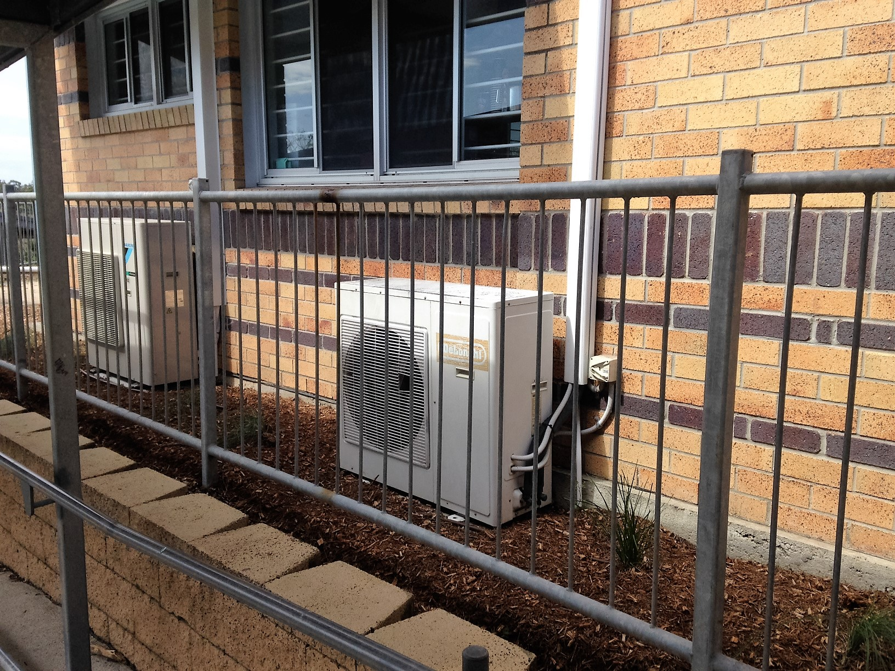

Fig. 1 : The air-conditioning unit on the external wall of Shades Cafeteria.

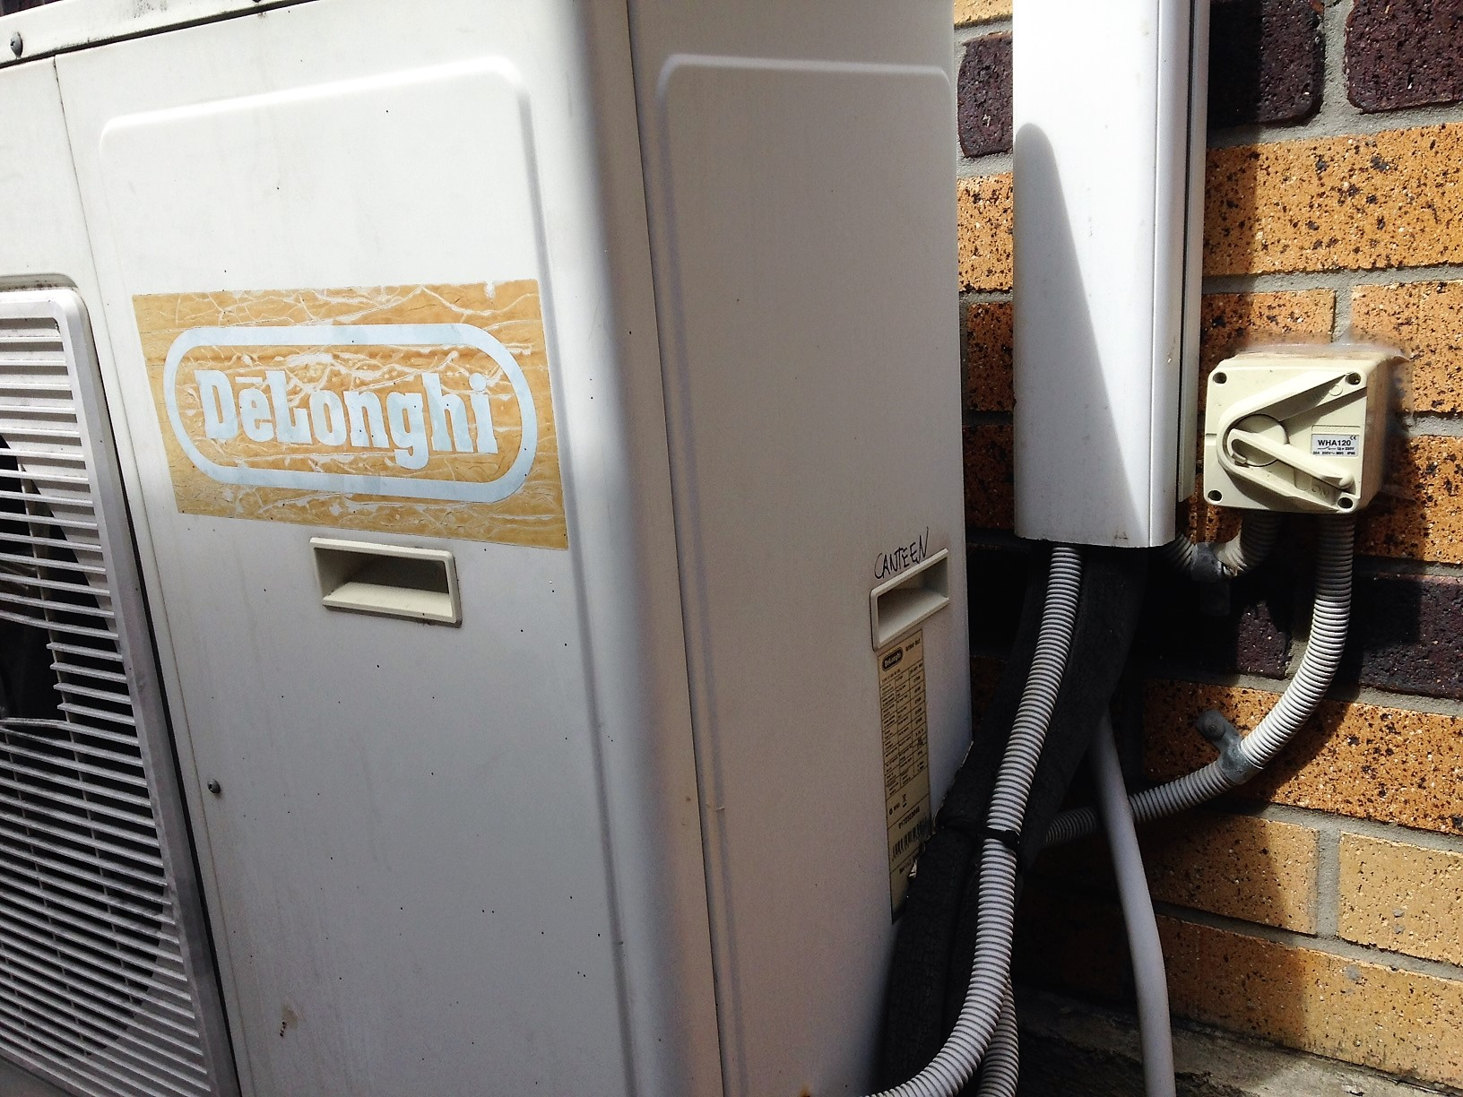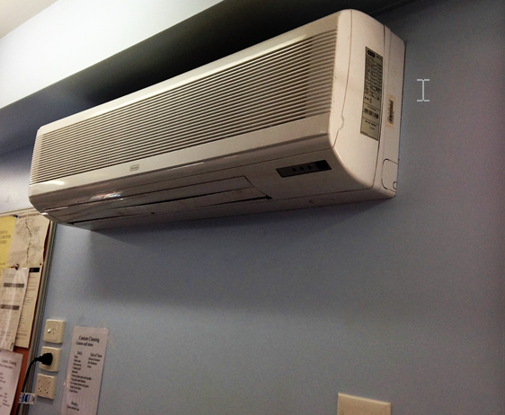

Fig. 2 : The faulty isolation switch beside the air-conditioning unit.
Fig. 3 : Inside the food preparation and kitchen area with the internal wall mounted section of the air-conditioning unit where the Technician came in contact with live components.

4.7 Timeline

Fig. 4 : Timeline summary of events

5.0 Data Collection
Data was gathered to identify the relevant facts surrounding the incident using the principles, techniques, and methodology of the 5 Whys Data Collection process focusing on the five data categories known as the “PEEPO” process. These five data categories are:
- People;
- Environment;
- Equipment;
- Procedures; and
- Organisation
The basis of the data collection is to establish details of the incident and determine the contributing and non-contributing factors to the incident.

5.1 People
The personnel associated with the incident and/or activities and process impacting on the incident occurring on 30 November 2021 were interviewed providing statements and/or were subject to discussions. These personnel are detailed in Table 5.1.

Name | Position | Company
[Name] (Injured Person) | Technician | A&C Aircon and Electrical
[Name] | Supervisor | A&C Aircon and Electrical
[Name] | Technician | A&C Aircon and Electrical
[Name] | Technician | A&C Aircon and Electrical
[Name] | Head Chef | Shades Cafeteria

Table 5.1 - Personnel interviewed and/or subject to discussions

5.1.1 Supervision and Work Instructions
The A&C Aircon and Electrical Supervisor assigned the Technician the work to carry out repairs to the faulty air-conditioning unit at Shades Cafeteria, Westbank Private Hospital. The Technician first attended Shades Cafeteria on 18 November to inspect the air-conditioning unit and returned on 30 November to carry out the approved repair work.
The Technician has the appropriate Queensland Electrical Work Licence and has conducted electrical and air-conditioning work at the Hospital several times over the previous 3 years.
It is typical for A&C Aircon and Electrical to assign one suitably qualified technician to perform this work.
This work was a routine air-conditioning repair having a general maintenance Safe Work Method Statement (SWMS) for this work.

5.1.2 Role, Training, and Experience
The details of the Technician involved in the incident and the Supervisor assigning the work are described below.
- Technician, [Name]:
  - Employed by A&C Aircon and Electrical since October 2018 having 3 years’ experience with A&C Aircon and Electrical carrying out a range of electrical and air-conditioning work across various organisations.
  - Experience in this field of work spans 15 years.
  - Current Queensland Government Electrical Work Licence:
Licensed electrical fitter/mechanic
Number - 12345
Expiry Date - 21/03/2022
  - Current National Refrigerant Handling Licence
Number - 321
Expiry Date - 11/04/2023
  - Onboarding training received:
A&C Aircon and Electrical Induction
Westbank Private Hospital Induction (Current with expiry 06/07/2022
A&C Aircon and Electrical Hazard and Risk Management
  - Did not carry out a “test for dead” and relied upon the isolating switch to de-energise the air-conditioning unit.
  - Signed on to the SWMS acknowledging an understanding of how the work was to be performed.
  - Received an electric shock to his left hand and did not immediately report the incident to his Supervisor nor immediately seek medical assessment. Instead, he rested for 15 minutes then completed the repairs and testing. He returned to A&C Aircon and Electrical premises and reported the incident approximately 4 hours after he received the electric shock.
- Supervisor, [Name]:
  - Employed by A&C Aircon and Electrical since October 2013.
  - Been in his present role as Supervisor for approximately 2 years.
  - His role is predominantly quoting for jobs and work scheduling.
  - Current Queensland Government Electrical Work Licence:
Licensed electrical fitter/mechanic
Number - 67891
Expiry Date - 27/06/2023
  - Current National Refrigerant Handling Licence
Number - 789
Expiry Date - 10/10/2023
  - Assigned the Technician the work because he was familiar with the work conditions and processes at the Hospital.
  - The issued work order for the Technician provided a realistic time frame to complete the repairs.
  - Aware that it is common practice for technicians to rely on the isolating switch for de-energisation; however, assumed each Technician would “test for dead” prior to commencing the repair work.
  - He does not get out on the job at sites very often to observe technician’s work. When on site it is mainly quoting on jobs.

5.1.3 Personnel Incident Reporting
- The Technician did not immediately cease work and report the incident to the A&C Aircon and Electrical Supervisor. After receiving an electric shock all work must cease and the injured person must immediately seek a medical assessment as required by A&C Aircon and Electrical procedures.
- When the incident was reported to A&C Aircon and Electrical, the Supervisor immediately drove the Technician to the City West Medical Centre for medical assessment.

5.1.4 Other Factors
- Based on observation only from witness statements, there were no fitness for duty issues, such as alcohol, other drugs, and fatigue.

5.1.5 Conclusions
- The Technician relied upon the isolating switch only for de-energisation of the air-conditioning unit and did not “test for dead” prior to commencing the repairs.
- A&C Aircon and Electrical Supervisor is aware that the technicians isolate using the isolation switch; however, assumed they each “test for dead.”
- The Supervisor relies on the technicians following the SWMS. Does not do any formal checks on their work.
- The A&C Aircon and Electrical incident management procedures were not adequately applied by the Technician when he completed the repairs before reporting the incident and seeking medical assessment.

5.2 Environment
The environmental conditions were identified to understand the conditions in place at the time the incident occurred. These include:

5.2.1 Air-conditioning Unit Location
- Isolating switch located next to the external air-conditioning unit.
- The mains switchboard is easily assessable and located on the opposite side of the building.
- The wall mounted section of the air-conditioning unit is located inside the building. This did not cause any concern with Cafeteria staff working in area.

5.2.2 Conclusions
There were no environmental matters the contributed to the incident.

5.3 Equipment

Air-conditioning Unit
The details of the air-conditioning unit are described below:
- Delonghi Split System Air-conditioning Unit.
- Model No. - DPWI DCT 70E.
- Faulty isolating switch - no visible external indication of a fault.

5.3.2 Conclusions
The air-conditioning isolating switch, used as the primary isolation point, was faulty and this was not known by the Technician when he started the repair work.

5.4 Procedures
A&C Aircon and Electrical processes and procedures relating to air-conditioning maintenance and/or isolation were reviewed to establish any aspects that may have contributed to the incident. The following documents were reviewed which include:
- Positive Effective Isolation Procedure - Document No. P0019.
- A&C Aircon and Electrical Risk Register with regard to electric shock risk control measures.
- Life Saving Rules.
- SWMS - General Maintenance for Air-conditioning Units - Document No. S0009.
- Field Risk Assessment.
- Incident Management Procedure - Document No. P0002

5.4.1 Electrical Isolation
- The SWMS, General Maintenance for Air-conditioning Units, states “after isolating always test for dead before commencing the work.”
The SWMS only mentions to isolate at the isolating switch. It does not state to isolate at the mains switchboard.
- The Risk Register states the control to prevent the risk of an electric shock is to ensure positive isolation by testing for dead (de-energisation) once the isolating switch is in the “off” position. This control cascades across the hierarchy of documents aligning with:
  - Item 5 from the Life Saving Rules;
  - Positive Effective Isolation Procedure; and
  - SWMS, General Maintenance for Air-conditioning Units.
- The field risk assessment was not adequately applied with reliance only on the isolation switch for de-energisation without “testing for dead.”

5.4.2 Incident Reporting
- The process after receiving an electric shock was not adequately applied by the Technician as per A&C Aircon and Electrical Incident Management Procedure, No. P0002. The Procedure states: “after receiving an electric shock, immediately stop work and seek medical assessment.”

5.4.3 Conclusions
- The A&C Aircon and Electrical documentation state that effective positive isolation is verified by “testing for dead.” This is not always carried out and technicians rely upon the isolating switch always to be effective.
- The SWMS only relies upon the isolating switch for de-energisation. The mains switchboard should be included in the SWMS as the primary isolation point which ensures positive effective isolation.
- There is diminished operational discipline by technicians and supervisors allowing non-conformances to process regarding actively “testing for dead.”
- There is reliance in the SWMS without performing a pre-start risk assessment.
- The actions taken by the Technician after receiving an electric shock were not adequately applied as per the Incident Management Procedure, No. P0002. It was approximately 4 hours after the event that the Technician received medical intervention.

5.5 Organisation
A&C Aircon and Electrical systems and processes impacting on the activity at the time of the incident are included in the following:

5.5.1 Procedures and Risk Management
- The A&C Aircon and Electrical Document Hierarchy identifies and states the requirements for “testing for dead” and “ensuring positive effective isolation.”

5.5.2 Accountability and Responsibility
- There is reduced accountability and responsibility with respect to:
  - “Testing for dead” on jobs considered not too complex;
  - Supervision to ensure process is followed; and
  - Incident reporting and seeking medical assessment after receiving an electric shock.
- There is a tolerance to not follow procedures with diminished operational discipline to the application of process.

5.5.4 Previous Incident
- A&C Aircon and Electrical notified the Regulator of an electric shock following an event occurring approximately 4 years ago; however, this was later identified as being static electricity.

5.5.5 Conclusions
- The control measures identified to control the risk of an electric shock is inconsistently applied as detailed in Section 5.5.2.
- Insufficient monitoring of work to ensure the application of the procedures/SWMSs is adhered to.

6.0 Key Findings
The key findings outline why the incident occurred and the contributing factors identified from the investigation are defined using the 5 Whys Methodology. The 5 Whys determines the deficient Organisational Factors or root causes that led to the incident.

6.1 Basic Cause
The basic cause of the incident was ineffective isolation by the Technician while carrying out maintenance work to repair an air-conditioning unit. This resulted in the technician receiving an electric shock to his left hand.
This basic cause combining with the following contributing factors led to the incident.

6.2 5 Whys Analysis
Based on the evidence to hand, Figure 5 outlines the main contributing factors to the incident in the 5 Whys Chart. The timeline used is a condensed version of the Timeline, detailed in section 4.7, to include key events surrounding the incident.
Note: The Organisational Factors are detailed in the Safety Wise Solutions 5 Whys Pocket Investigation Guide; page 36. The deficient Organisational Factors identified include:
- RM - Risk Management
- OR - Organisation
- PR - Procedures

Fig. 5 : 5 Whys Chart detailing the contributing factors.

7.0 Recommendations
The following recommended corrective actions are proposed for consideration. The recommendations address all the Organisational Factors identified in the 5 Whys analysis These recommendations are applicable to Business Group or site and could benefit other Company group operations.

7.1 Communication via Safety Alert (Administration)
Issue and communicate a Safety Alert (or other suitable communication method) to all staff as appropriate by management, explaining what occurred, the basic cause, and the actions that have been taken as well as those that are to be taken. Emphasise staff responsibilities, applying good operational discipline to follow work instructions, and the importance of “test for dead” and immediate incident reporting.
7.2 Procedures (Administration)
Review and modify the SWMS - General Maintenance for Air-conditioning Units - Document No. S0009 to include “must isolate at mains switchboard.”

7.3 Risk Management
Develop a process to ensure the field risk assessment is conducted and applied as per the specified risk mitigation strategies to ensure positive effective isolation and “test for dead” is performed before work commences.
Provide training sessions covering the process to all relevant personnel.

7.4 Accountability and Responsibility
Review and modify technician and supervisor position descriptions regarding responsibilities and accountabilities, specific to electrical risk management, such as adherence to procedure, positive effective isolation and “test for dead.”
Review current incident reporting requirements and include a process to ensure all personnel are accountable for reporting incidents aligning to their agreed responsibilities.
Ensure responsibilities are clearly defined and provide support with targeted coaching / training in these areas.

7.5 Behavioural Markers
Review and modify behavioural markers as required to ensure that employees are fully aware of the safe behavioural requirements of the A&C Aircon and Electrical Management. The development should include the following elements:
- clearly defined expectations of behaviour;
- effective communication of safety related information;
- guidance on risk assessment and acceptance;
- the right and duty to intervene on unsafe acts and conditions;
- personal accountability for safe behaviours; and
- process to develop, encourage and sustain safe behaviours.
These elements should carry across the full organisation structure including management decision making.

8.0 Management Review of the Investigation Report

8.1 Management Review
The management of Business Group, site and Project should formally review the investigation report for completeness, quality of the investigation and to endorse the recommendations with aligned corrective actions. It is recommended that the following action plan is implemented:

8.1.1 Distribution
To maximise the preventative potential of the investigation report, the findings and conclusions of the report should be distributed as widely as practicable internally within Company Business Groups and externally to industry bodies.

8.1.2 Implementation of Corrective Actions
Corrective actions addressing the recommendations shall be formally presented to the Responsible Line Manager for implementation. An action plan and timeframe shall be agreed and endorsed by the appropriate level of management. An action plan is attached in Appendix 10.1 of this report.

8.1.3 Implementation Monitoring
The completion of corrective actions must be documented and communicated by the Responsible Line Manager to the Site Senior Executive, and in turn to the Safety Manager. Where corrective actions have not been fully implemented, ongoing monitoring should be maintained until implementation is complete.

8.1.4 Analyse Effectiveness
The effectiveness of the corrective actions should be evaluated by a review of safety performance and through an audit within the next six months whereby a report will be prepared for management to detail compliance and progress achieved.

8.1.5 Document Archival
Investigative data and reports shall be archived in accordance with site and regulatory requirements.

9.0 Significant Learnings
The investigation has raised several key learnings which are covered in the body of the report.
The significant learnings for A&C Aircon and Electrical are:

9.1 Isolation
Always ensure positive effective isolation by “testing for dead” after isolation switches are applied.

9.2 Accountability and Responsibility
Although the organisation has systems and processes in place and applicable to tasks, these must be supported with high level operational discipline across all personnel at all levels of the organisation to ensure the integrity and application to a safe and efficient workplace.

9.3 Incident Reporting
Incidents must be reported in an effective, timely, and consistent manner to ensure risks have been identified and addressed to minimise the risk of recurrence. The appropriate people must be informed, and learnings be disseminated across the business ensuring continual improvement across the business.

10.0 Appendices

10.1 Corrective Action Plan
To be completed in consultation with A&C Aircon and Electrical line management and approved by management to determine the appropriate corrective actions, from the recommendations provided, for the business.

Item Ref | Recommendation |  | Responsible  Department | Responsible Person | Completion  Date | Sign off
7.1 | Communication via Safety Alert
7.2 | Procedures
7.3 | Risk Management
7.4 | Accountability and Responsibility
7.5 | Behavioural Makers
General Manager’s Close out of Incident - All corrective actions have been completed, where corrective actions have not been fully implemented, the following measures have been put in place to ensure ongoing monitoring until implementation is complete.
Name: |  | Signature: |  |  | Date:

11.0 Report Sign-off
To maximise the preventative potential of the investigation report, the findings and conclusions of the report should be distributed to the various people involved in the incident and as widely as practicable.
The completion of corrective actions must be documented and communicated by the Responsible Line Manager to the Site Senior Executive, and in turn to the Safety Manager. Where corrective actions have not been fully implemented, ongoing monitoring should be maintained until implementation is complete.

Feedback to the Involved Person(s) and comments:
Name: | Signature: | Date:
Feedback to the Involved Person(s) Supervisor(s) and comments:
Name: | Signature: | Date:
Department Manager’s acceptance of findings and comments:
Name: | Signature: | Date:
Safety Manager’s acceptance of findings and comments:
Name: | Signature: | Date:
Site Senior Executive’s acceptance of findings and comments:
Name: | Signature: | Date:

